Design Document

1. Introduction

1.1 Purpose of the Document
This design document describes how the ArtoFest festival guide and planner will be implemented. It translates the initial project overview into a detailed design, covering:
- Functional and non-functional requirements
- System architecture and major components
- Data and database design
- User interface and navigation
- Technology stack
- Testing approach
- Project management and risks
The document is intended for the client, supervisor, and development team as a shared reference during the COMP2003 project.

1.2 Project Background
ArtoFest aims to create a comprehensive festival guide and planner to help attendees navigate events, schedules and resources effectively. The guide will include individual festival profiles, maps, personalised planning tools and access to digital festival products.

1.3 Project Objectives
According to the project overview, ArtoFest has three main objectives:
- Develop a user-friendly festival guide with detailed event information.
- Provide a planner tool for attendees to customise their schedules.
- Enhance attendee experience through clear navigation and accessibility.

1.4 Scope
In scope:
- Individual festival profiles
- Filters (art form/genre, location, calendar setting, digital content)
- Wish list
- Planner tool (personal schedule)
- Streaming hub
- Redirection to ticket sales websites
Out of scope:
- Direct ticket sales within ArtoFest
- Festival forums or community discussion features
- Advanced personalisation beyond the planner / wish list during this project phase

2. Stakeholders
- Client Representatives:
  - Nadia Krasteva
  - Russell Howe
- Project Supervisor:
  - Dr Haoyi Wang
- Design and Development Team:
  - Favour Akuchie
  - Idowu Adeleke
  - Jacob Askew
  - Paul Oko-Jaja

3. User Needs and Requirements

3.1 Target Users
- In-person Festival Attendees
  - Need to discover festivals, view event details and plan schedules around dates and locations.
- Prospective Attendees
  - Need clear, attractive information to help decide whether to attend a festival.
- Online / Streaming Audience
  - Need easy access to digital festival products and streaming links.

3.2 User Stories
Below are core user stories that drive the functional requirements:
- As a user, I want to browse a list of festivals so that I can see my options.
- As a user, I want to filter festivals by location and date so that I can find events near me at suitable times.
- As a user, I want to filter festivals by art form or genre so that I can focus on my interests.
- As a user, I want to open a festival profile so that I can see detailed information, schedule, location and digital content.
- As a user, I want to add festivals or events to a wish list so that I can easily return to them later.
- As a user, I want to create a personal plan of events so that I know what I am attending and when.
- As a user, I want to access a streaming hub so that I can view digital or streamed content linked to festivals.
- As a user, I want to follow a link to buy tickets so that I can purchase access directly from official providers.

3.3 Functional Requirements
Festival browsing and discovery
- FR1: The system shall display a list of festivals.
- FR2: The system shall allow users to filter festivals by location.
- FR3: The system shall allow users to filter festivals by date or date range.
- FR4: The system shall allow users to filter festivals by art form and/or genre.
- FR5: The system shall allow users to filter festivals by availability of digital/streaming content.
Festival profiles
- FR6: The system shall display a festival profile page, including description, location, dates and imagery.
- FR7: The system shall display associated events (if implemented) for each festival.
- FR8: The system shall display links to streaming/digital content where available.
- FR9: The system shall display links to external ticket sales websites.
Wish list
- FR10: The system shall allow users to add festivals (and optionally events) to a wish list.
- FR11: The system shall allow users to view their wish list.
- FR12: The system shall allow users to remove items from the wish list.
Planner tool
- FR13: The system shall allow users to create a personal plan/schedule.
- FR14: The system shall allow users to add festivals or events to their plan.
- FR15: The system shall allow users to view their plan as a list or simple calendar-style layout.
- FR16: The system shall allow users to remove items from their plan.
Streaming hub
- FR17: The system shall provide a streaming hub page that lists festivals with digital content.
- FR18: The streaming hub shall display links or embedded players for relevant content where possible.
User accounts (if implemented)
- FR19: The system shall allow users to create an account (register).
- FR20: The system shall allow users to log in and log out.
- FR21: Wish lists and plans shall be associated with the logged-in user.

3.4 Non-Functional Requirements
Usability
- NFR1: The interface shall be intuitive and navigable by first-time users without a tutorial.
- NFR2: Key actions (search, filter, add to planner/wish list) shall be accessible within 2–3 clicks from the home page.
Performance
- NFR3: Festival list and profile pages shall load within 3 seconds on a standard broadband connection under normal load.
- NFR4: Filtering operations should complete within 1 second on average data sets used in this project.
Reliability
- NFR5: The system shall handle missing or incomplete festival data gracefully (e.g. if a festival has no streaming content, the streaming section should be hidden or show a suitable message).
Compatibility and Accessibility
- NFR6: The site shall be responsive and usable on both desktop and mobile screen sizes.
- NFR7: The site shall use accessible colour contrasts and font sizes; alternative text descriptions shall be provided for important images.
Security
- NFR8: User passwords (if accounts are implemented) shall be stored as hashed values.
- NFR9: Input validation shall be applied to user input fields to prevent basic injection attacks.
4. System Architecture
Overview
The ArtoFest platform is designed as a modern, modular web application following a three-tier architecture:
- Frontend (Presentation Layer)
Handles all user interaction, displaying festival listings, profiles, filters, wish lists, planners, and streaming pages.
- Backend API (Application Layer)
Processes business logic, manages user accounts, filters festivals, stores planner items, and serves streaming content metadata.
- Database (Data Layer)
Stores all persistent information such as users, festivals, events, wish list items, planner schedules and streaming content.
This separation ensures scalability, easier maintenance, and clear role boundaries.
Component Breakdown
Festival Management Component
- Provides list of all festivals
- Supports filters (location, date, genre, price)
- Connects to festival details such as events, performers, ticket links
- Fetches official URLs and media for festival profiles
Festival Profile Component
- Displays full festival details
- Shows location map, dates, performers, events
- Provides links to ticket providers
- Integrates a "Live Stream" option if available
Filter & Search Component
- Filters festivals by:
  - Location
  - Genre
  - Start date
  - Cost / Ticket availability(Cost is optional)
- Supports keyword search
- Implements combined filtering logic via backend queries
Wish List Component
- Allows users to save festivals they are interested in
- Stores wish list items associated with authenticated users
- Retrieves saved items on login
Planner Component
- Let users add festival events to a personal schedule
- Displays selected events in a calendar-style view
- Prevents time clashes where possible
- Synchronises with user account
Streaming Hub
- Central page for online live streams
- Lists all currently live or upcoming streams
- Uses embedded video players (e.g., YouTube Live or custom stream link)
- Shows performer information linked to the main database
User Management Component
- User registration / login / logout
- Stores hashed passwords
- Manages sessions / tokens
- Authorises access to planner and wish list features

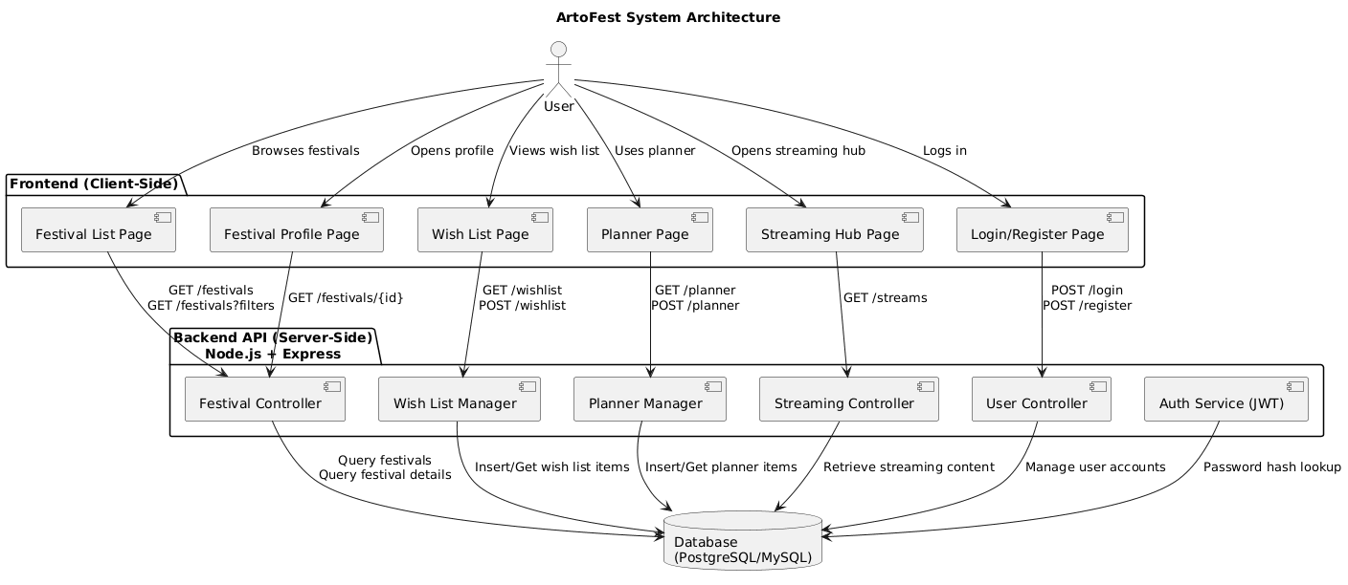
┌──────────────────────────┐
│ Frontend │
│ (HTML, CSS, JS/React) │
│──────────────────────────│
│ - Festival List │
│ - Festival Profile │
│ - Filters & Search │
│ - Wish List │
│ - Planner │
│ - Streaming Hub │
│ - User Login/Register │
└──────────────┬──────────┘
│ REST API calls (JSON)
┌──────────────▼──────────┐
│ Backend API │
│ (Node.js/Express) │
│──────────────────────────│
│ - Festival Controller │
│ - User Controller │
│ - Wish List Manager │
│ - Planner Manager │
│ - Streaming Controller │
│ - Authentication Service │
│ - Validation & Security │
└──────────────┬──────────┘
│ SQL Queries
┌──────────────▼──────────┐
│ Database │
│ (MySQL/Postgres) │
│──────────────────────────│
│ - users │
│ - festivals │
│ - events │
│ - wish_list_items │
│ - planner_items │
│ - streaming_content │
└──────────────────────────┘
5. Detailed Design
Festival Browsing Workflow
Purpose: Allows users to explore festivals and apply filters.
Workflow:
- User visits Festival List page
- Frontend calls GET /festivals
- Backend fetches festivals from DB
- User applies filters
- Frontend calls GET /festivals?location=x&date=y&genre=z
- Backend returns filtered results
- Page updates dynamically
Inputs: Selected filters
Outputs: Filtered festival list

Festival Profile Workflow
Purpose: Provide detailed information on a single festival.
Workflow:
- User clicks a festival
- Frontend calls GET /festivals/:id
- Backend retrieves:
  - Festival details
  - Events
  - Performers
  - Ticket links
  - Streaming links
- Data rendered on the Profile page
Inputs: Festival ID
Outputs: Festival details

Wish List Workflow
Purpose: Allow users to mark festivals of interest.
Workflow:
- User clicks “Add to Wish List”
- Frontend sends POST /wishlist with festival ID
- Backend checks user token
- Backend stores item in DB
- Wish list page calls GET /wishlist to refresh
Inputs: Festival ID, User ID
Outputs: Updated wish list

Planner Workflow
Purpose: Build user's personal event schedule.
Workflow:
- User adds an event to planner
- Frontend sends POST /planner
- Backend validates time conflicts
- Item stored in DB
- Planner page retrieves items via GET /planner
Inputs: Event ID, date/time, User ID
Outputs: Planner view

Streaming Hub Workflow
Purpose: Provide access to live stream content.
Workflow:
- User opens Streaming Hub
- Frontend calls GET /streams
- Backend returns stream info (URL, performer, time)
- User selects a stream
- Player loads embedded video
Inputs: Stream ID
Outputs: Playback session
6. Technology Stack (Backend & Architecture)
Backend
- Node.js + Express.js
Suitable for fast REST API development and integrates well with JSON-based frontends.
Database
- PostgreSQL (or MySQL)
Ideal for relational data structures and fast filtering queries.
ORM
- Prisma or Sequelize
Helps map JS objects to SQL tables.
Authentication
- JWT (JSON Web Tokens)
Supports secure login sessions.
Hosting
- Render / Railway / GitHub Pages (frontend)

7. User Interface Design

7.1 Key Pages
1. Home Page
- Brief introduction to ArtoFest.
- Navigation links to:
  - Browse Festivals
  - Streaming Hub
  - My Planner
  - My Wish List
- Optional featured festivals section.
2. Festival List / Search Page
- Search bar (keyword search).
- Filter controls:
  - Location (dropdown or free text)
  - Date / date range
  - Art form / genre
  - “Has streaming content” checkbox.
- Grid or list of festival cards (name, image, location, dates, link to profile).
3. Festival Profile Page
- Festival banner image and title.
- Overview section (dates, location, description).
- Section for schedule/events (if implemented).
- Buttons:
  - “Add to Wish List”
  - “Add to Planner” (for events).
- “Streaming & Digital Content” section with cards or links.
- “Tickets” section with external links.
4. Planner Page
- Shows list of planned events/festivals in chronological order.
- Option to remove or edit items (e.g. notes).
- Simple calendar-style or list view.
5. Wish List Page
- Displays all saved festivals/events as cards.
- Each card links back to the relevant festival profile.
- Remove button to delete items from the list.
6. Streaming Hub Page
- Displays festivals or content entries that have digital/streaming content.
- Each card shows title, brief description and link/embedded player.
7. Authentication Pages (optional)
- Login page (email + password).
- Registration page (name, email, password, confirm password).

7.2 Navigation Structure (Text Sitemap)
- Home
  - Festivals
    - Festival List
    - Festival Profile
  - My Planner
  - My Wish List
  - Streaming Hub
  - Login / Register (if using accounts)

“Jacob you can paste here”

10. Project Management

10.1 Phases & Deliverables
From the project overview, the key deliverables are:
- Site Map
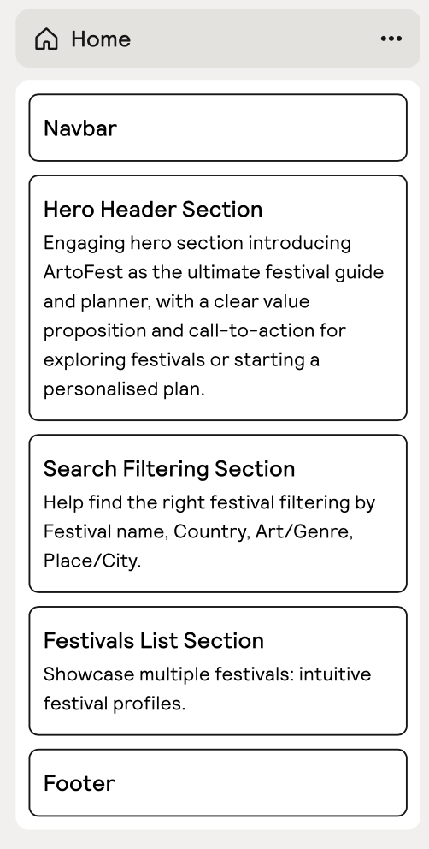

- Design Mock-ups

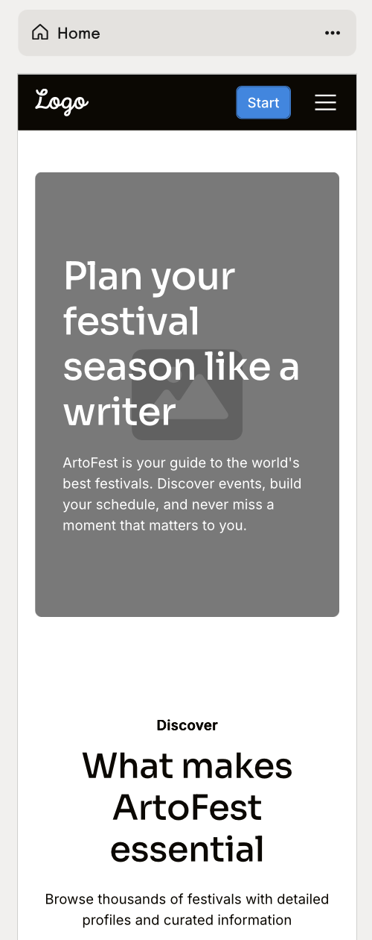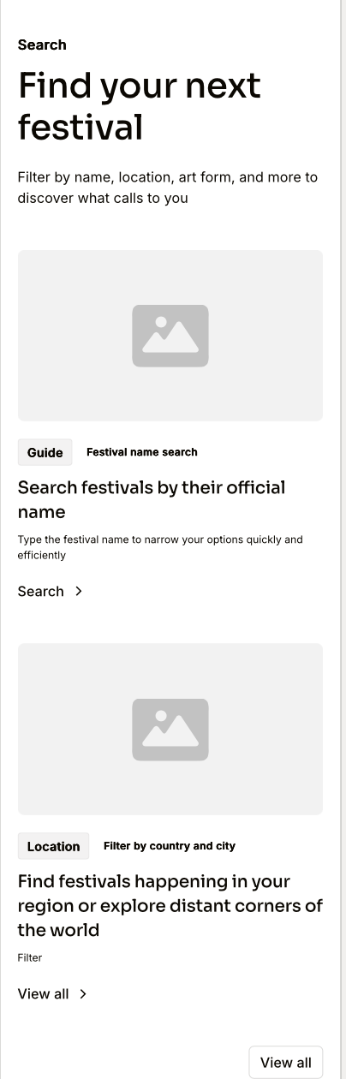

- Complete Version
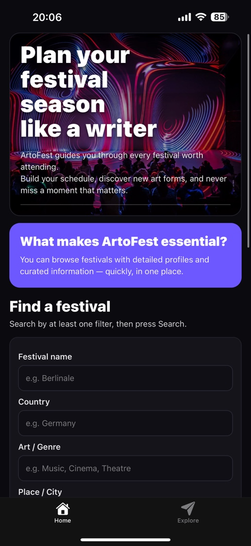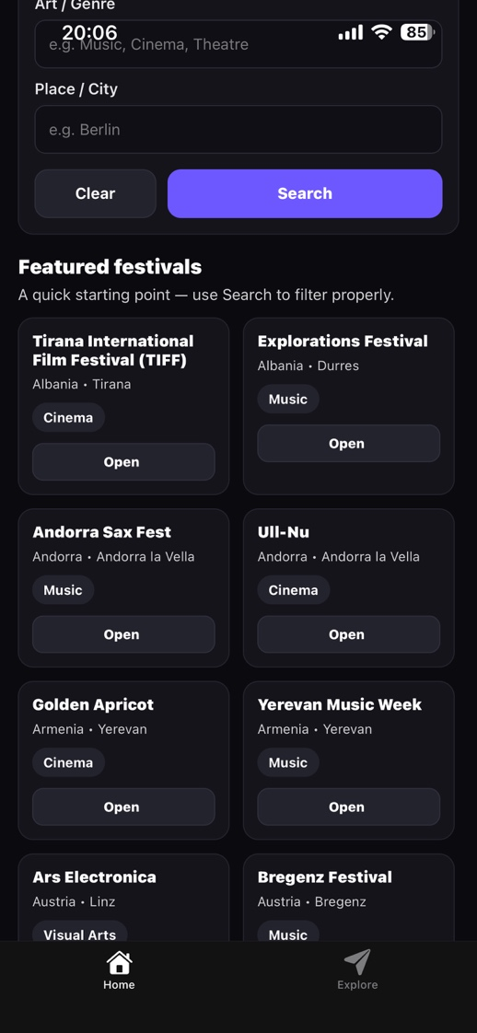
All deliverables will be produced in accordance with the COMP2003 module schedule.

10.2 Team Roles
- Favour Akuchie –UI and UX Designing
- Idowu Adeleke – Backend Developer
- Jacob Askew – Frontend Implementation
- Paul Oko-Jaja – Project Manager and documentation

10.3 Development Process
- Use a light Agile / Scrum-inspired approach:
  - Short sprints focused on specific features (e.g. festival listing, profiles, planner, streaming hub).
  - Weekly stand-up meetings to review progress and blockers.
  - Use Trello or similar tool to track tasks: To Do, In Progress, In Review, Done

11. Risks and Mitigation
Risk | Impact | Likelihood | Mitigation
Limited development time | High | Medium | Prioritise core features (festival list + profiles + basic planner).
Difficulty integrating streaming media | Medium | Medium | Start with simple external links; only implement embedded players if time.
Incomplete festival data | Medium | Medium | Design UI to handle missing data gracefully with placeholders/messages.
Uneven workload across team members | Medium | Medium | Clearly assign tasks, monitor via Trello, and review in weekly meetings.
Technical issues with hosting | Medium | Low | Test deployment early; use simple, well-documented hosting solutions.

